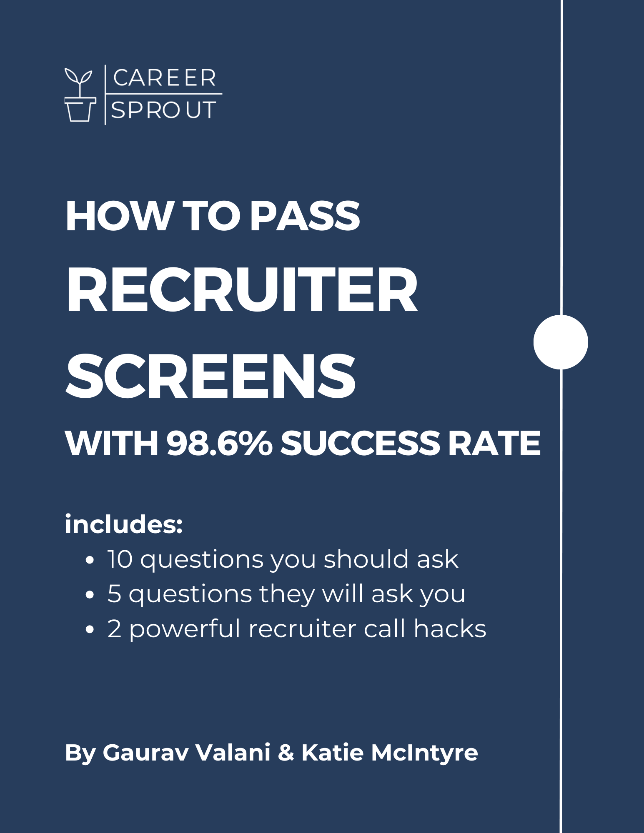

# This guide is broken down into 4 sections:

1. The 10 questions you should ask a Recruiter
2. The 5 questions they will ask you
3. 2 powerful Recruiter call hacks

# 10 Questions to Ask a Recruiter

Recruiters are so close to the hiring process and possess information about the teams/hiring managers you'll work with, that their insights can help you unlock information that will come in handy.

1. Have you placed someone in a similar role at this company? Or on this team?
2. What are some of the soft and hard skills/past experiences that are important to this team and/or the Hiring Manager?
3. Can you tell me more about the interview process?

* How many rounds will there be?
* Who will I be meeting with in each round?
* Which rounds will require a presentation?

1. If I were to start tomorrow, what problem would I be solving within the first 30 to 60 days?
2. What can you tell me about the Hiring Manager in general?
3. Between now and my interview w/ the hiring manager, is there anything you recommend that I read up on to help me better prepare for the interview?
4. Would you be able to share some past projects this team has worked on so I can research them?
5. What do you like about working at this company?
6. What specifically about my background caught your attention?
7. Anything that I didn't ask you that I should have?

# 5 Questions Commonly Asked by Recruiters:

These are the 5 questions that a Recruiter will ask you in this call:

1. Why are you looking?
2. What are you looking for?
3. Why us?
4. What are your salary expectations?
5. Can you tell me about yourself?

## Why are you looking + What are you looking for:

**Here's a great response:**

*Unfortunately, I was part of a company-wide layoff. Even though I was disappointed to leave such a great team, it turned out to be a blessing in disguise, giving me a chance to reassess my career goals and the level of impact I want to make in my next role. So now I'm in a great position to be really intentional about the next steps in my career. That's why I'm excited about the potential at Company XYZ, where I see a clear opportunity to apply my skills and make a difference. But I'm curious to hear from you, what does success in this role look like from your perspective?*

## Why are you interested in working here?

As a standalone response, you should talk about why you as a human align with this company’s mission, vision, values, and how you’re excited about the work they are doing and you would be doing.

**Here's a great response:**

*When I look back throughout my career, I found that I was the most engaged and happiest when I got to help company XYZ build their SaaS platform. It was an incredible endeavor that helped us generate over $11M in ARR and transformed how we did business going forward. The fact that building out a SaaS platform is your #1 priority, I can't help but to get excited about how it can transform your company, too and it's something that I want to be a part of from the beginning and see through to completion. I also feel like with the team you have in place plus the experience that I have working on this, there is a lot of synergy there.*

## What are your salary expectations:

*Salary is not my number one motivator, and I'm much more interested in looking to join an organization in which I can continue to learn about something that personally excites me, work with a great team, have opportunities for growth, and utilize my strengths and experience to make a long-lasting impact.*

*That being said, in full transparency, the positions that I'm currently interviewing for right now are offering between $206,000 and $237,000.*

2 reasons why this is such a great response:

* It shows the Recruiter that you're a savvy shopper and that you've done your research on comp / what your value is in the open market.
* It also tells the Recruiter that you're currently out there interviewing, which then creates more of a sense of urgency on their part

## Can you tell me about yourself:

This is not an opportunity for you to go into your entire life story (not to say it isn't important ), but rather to reiterate that what THEY need is what YOU have; so keep it to only what is relevant for them.

### Part 1: Introduce yourself professionally with your title in 1-2 sentences

Example:

*I’ve been in {{industry/role}} for the last {{x years}}, and I’ve been so fortunate to work with and learn from incredible leaders at great companies like {{company names}}.*

### Part 2: Share your journey emphasizing the human emotions + highlight reel of your DLA

(DLA = Did. Learned. Achieved). Everything you share here should be relevant to the role you’re interviewing for and answer the questions:

* Can this person do the job?
* Can I work with this person every single day?

It’s extremely important that you aren’t bragging in this section. Instead use the DLA framework:

Here’s what I did. Here’s what I learned. Here’s what WE achieved.

Example:

*When I started off in {{role}} at {{company}}, they had brought me in to {{do}}. And it was a phenomenal experience because I got to work with such great leaders and other great project managers who had been in the business much longer than me. So I learned from them {{Learned}}. It was brutal in the beginning but thanks to all the mentors I had, it was a really good environment to learn how to be a strong {{title}}. And as a result, what I’m most proud of is we were able to {{Achieve}}.*

*And then from there I was recruited by Company XYZ where I worked with some of their top clients to {{insert what you did}}. Company XYZ was really such a great place for me to grow up because I did feel like I was working with some of the best of the best and again I was just so fortunate to have such strong mentors. Not only was I able to leverage my past experience, but now I was {{Doing and Learning}}. Don’t get me wrong, it was absolutely terrifying haha, but I’m proud to say that even there we were able to {{Achieve}}*

*Which brings us to today where in my most recent role I was also a project manager at company {{insert DLA}}*

### Part 3: Why you’re here (1-2 sentences on why this is a compelling opportunity).

Example:

*And the reason I’m so excited to speak with you about this opportunity is because it sounds like I would be able to leverage all of my experience and be able to make a strong impact, but I would love to hear in your own words - what does success in this role look like from your perspective?*

### Tell Me About Yourself example:

*I’ve been in project management for the last 8 years, and I’ve been so fortunate to work with and learn from incredible leaders at great companies like Company XYZ.*

*When I started off in project management at xyz company, they had brought me in to manage multiple projects simultaneously for their xyz team.*

*And it was a phenomenal experience because I got to work with such great leaders and other great project managers who had been in the business much longer than me. And I learned from them how to manage multiple projects simultaneously, how to gather good requirements, how to create strong project documents and artifacts, how to run scrum meetings, how to provide project updates, how to anticipate risks and escalate risks as needed, and just how to work cross-functionally across business, analytics, product, engineering, etc. It was brutal in the beginning but thanks to all the mentors I had, it was a really good environment to learn how to be a strong project manager.*

*And as a result, what I’m most proud of is we were able to deliver some high impact projects well ahead of schedule and even under budget. Some of those projects helped us (generate $X in revenue, helped us reduce costs $Y, etc).*

*And then from there I was recruited by Company XYZ where I worked with some of their top clients to implement xyz, and it was a pseudo project manager role where they had me (insert highlights)*

Company XYZ was really such a great place for me to grow up because I did feel like I was working with some of the best of the best and again I was just so fortunate to have such strong mentors. Not only was I able to leverage my past experience, but now I was being put in front of some Fortune 100 to 500 clients and I felt my executive presence skills were strengthened quite a bit. Just to sit in on meetings with Fortune 500 leaders and seeing how our managing partners would conduct those conversations etc

*Don’t get me wrong, it was absolutely terrifying haha, but I’m proud to say that even there we were able to deliver some high impact projects well ahead of schedule and even under budget. Some of those projects helped us (generate $X in revenue, helped us reduce costs $Y, etc).*

*Which brings us to today where in my most recent role I was also a project manager at company {{insert DLA}}*

*And the reason I’m so excited to speak with you about this opportunity is because it sounds like I would be able to leverage all of my experience and be able to make a strong impact, but I would love to hear in your own words - what does success in this role look like from your perspective?*

# Section 4: turn the Recruiter into your best friend

## Offer to write your own interview summary

The first thing a Recruiter is going to do after their call with you is submit your resume to the Hiring Manager. In addition to sending your resume, they are going to also write up a short summary explaining why they (the Recruiter) believe that you would be a good fit for the role.

This write-up can make or break your chances of actually getting in front of the hiring manager. Since it's critical, don’t leave your fate up to the Recruiter. Increase the odds of the subsequent interview actually happening:

Toward the end of the call, once the Recruiter says: "Great, I'm going to submit your resume to the team and get back to you shortly with feedback." You can say: Would it be helpful if I sent you over a short write-up explaining why I'm a good fit?

Most Recruiters will LOVE you for this because you're helping them do their job, which means, expect them to say "YES."

If/when they do, all you have to do is send them a write up and in that write up, simply use the 'Tell me About Yourself Response' above.

This way, you get to control your narrative and make sure that you share what you want the Hiring Manager to know.

## Offer to introduce them to candidates for other roles

If you REALLY want to impress the Recruiter (and ensure that you don't get ghosted afterwards), say this:

"Btw, what other positions are you currently recruiting for? I'd be happy to introduce you to anyone in my network that might be a good fit for them, or if you see anyone in my network that I'm connected to that could be a good fit, please let me know and I'd be happy to facilitate an introduction."

Why is this AWESOME?

Because Recruiters get measured by how quickly they fill positions. Their livelihood literally depends on it. How many positions they fill + how quickly they fill them dictates their commissions or bonus.

1. They will appreciate that you're trying to help them make more money
2. You come across as a generous human

I was a Recruiter for many years (longer than I care to admit) and I can guarantee you that:

1. Most people do not ask/offer this
2. And when they do, they immediately remain top-of-mind.

** NOTE: This should go w/o saying, but don't let this be an empty promise. Follow through on your offer if/when it makes sense**

# In Conclusion:

1. The call with a Recruiter is their first impression of you. Make it a good one.
2. Prepare for the questions above by building out your responses using the templates above
3. Do not forget to ask them the 10 questions shared above, so you can use the information to help you prepare for the subsequent interview rounds
4. Offer to send them a write-up prior to the call ending to make them fall in love with you + offer to introduce them to anyone in your network that might be a good fit for the other positions they are working on.

With these responses ready to go, you will not only make an awesome first impression, but you'll significantly increase the odds of securing the second, third, fourth, etc., interviews... and who doesn't want that? (rhetorical question)