**Resume Essentials – Writing a Strong Resume**

**May 14, 2024**

**Presented by LHH**

* **Your resume should communicate your value, LinkedIn should communicate your brand**
* **Two things your resume should communicate:**
  + Your value !!
  + Relevance to the job you’re posting for
  + *When putting together your resume, we should constantly be thinking does this highlight my value and is it relevant to the job?*
* **Parts of a resume:**
  + Heading and headline
  + ~~Objective Statement~~ – Objective statements are outdated, replace with…
  + Summary
  + Keyword table
  + Highlights (optional)
  + Employment history
  + Education
  + Professional development and training
  + Other categories: Memberships, Certifications, Licenses, Technical Skills, Publications, Patents, Languages, etc.
  + *The four highlighted items above are the most important parts of the resume. Think of them as your “professional movie trailer”.*
* **Summary Statement:**
  + **Communicate your value here**
  + **“Know thyself” first:** 
    - Create an inventory of anything/everything about yourself
    - This will also help to identify and/or strengthen brand too
  + **Avoid/Limit soft skills language:**
    - Examples: “Excellent communication skills”, “Goal-driven/detail-oriented”, “strong work ethic", "self-starter/multi-tasker” etc.
    - Only use soft skills language when it is clear it’s a skill or unique
      * Ex. Being able to communicate to executives and then implement at every level with X%/# of ___________
  + **Example of weak summary statement:**
    - “Enthusiastic, self motivated professional with extensive experience in the health care industry. Excellent analytical, interpersonal, organizational, and leadership skills. Team player with proven ability to develop effective working relationships at all levels of the organization and to deliver results on time and within budget. Strong verbal and written communication and presentation skills.”
  + **Example of a strong summary statement:**
    - “Business Operations Manager with 10+ years in new program creation, process design, and continuous improvement. Recognized for reducing order cycle time 47% from 19 to 10 days by collaborating across the supply chain, raising the company to #2 in market rankings. Best known for successful delivery sand implementations of new service offerings in a global multi-vendor call center environment.”
  + **A strong summary:**
    - Should be a show not tell
    - No more than 3 – 5 lines long
    - Start using adjectives right away to describe yourself
    - Do not need to include years of experience unless the job description specifically calls for it
    - Communicate your value!
    - Use ChatGPT to make summary statement more: action-oriented, accomplished, etc.
* **Skills Section**
  + Add skills right below the summary statement
  + List 9 – 12 skills (keywords from posting)
* **The first portion of resume should look something like:**

* **When writing resume think of writing the bullets as responsibility and accomplishment statements**
  + **Responsibility statement** – Overall, what were you responsible for in your job in one sentence
  + **Accomplishment statement** – Actions + Results
  + Include quantitative metrics where possible
    - If you cannot quantify, use strong words that show (not tell) the work you’ve done
  + These bullets are not bullet points of your job resume; again turn them into responsibility and accomplishment statements
    - Use ChatGPT to help with this

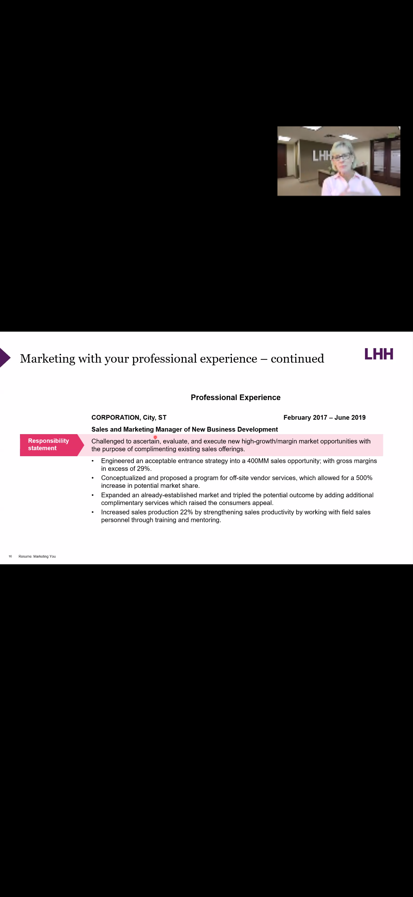

* + In the image above shows the accomplishment statements underneath the responsibility statement
* **Education Section**
  + Years attended is not needed
  + Include any additional coursework, certifications, etc.
* **Other Helpful Tips:**
  + **If you have 15+ years’ experience**, only include additional relevant experience outside of the 15-year window
  + **What formats and other items not to use when applying due to applicant tracking systems:**
    - Underling
    - Shading
    - Italics
    - Graphics
    - Color font
    - Borders
    - Photo
    - No header or footer section
  + **What you may continue to use when applying due to applicant tracking systems:**
    - Round bullets
    - Bold
    - Caps
    - ½ - 1” margins
    - 11+ point font
    - Sans Serif fonts
* **Think of SOAR Stories & Statements (especially if you have an interview):**
  + SOAR = **S**ituation | **O**bstacles or problems | **A**ction | **R**esults (ie how did it benefit the company)

